Dr. Claus W. Christoph Hanover, July 16, 2020
claus-w@christoph-www.de

Otto Schoerner

Otto Rudolph Herrmann Carl Franz Schoerner was born on September 2, 1839 in the Silesian town of Ohlau in Germany. On September 15, 1839, little Otto was baptized Catholic in the Catholic parish church Peter and Paul in Ohlau, which was only completed in 1836.
Source: Military church book for the 1st Silesian Hussar Regiment 4: "1839, No. 23: The son Otto Rudolph Herrmann Carl Franz Schörner, Catholic, son of Mr. Prem. Lieuten. Carl Schörner and his wife Ottilie born Tolksdorf, was born on 2 September 1839 in Ohlau, baptized on 15 September 1839 in the Catholic parish church [Peter and Paul] in Ohlau. Christening witnesses: Charlotte Beyer, [wife of the regiment doctor]; Baron [Wilhelm] von Schlichten, [cavalry captain]; Ferdinand Luchs, [tax collector] in Ohlau.“

Since 1349 the city of Ohlau was the residence of the Duchy of Ohlau. The city of Ohlau
of 1839 with only about 5,000 inhabitants formed the centre of the Ohlau district, which is why a regiment of hussars was stationed there. At that time, however, there were no barracks in Ohlau. The officers and soldiers lived with the citizens and craftsmen of the town. So lived the family of the then Prime Lieutenant of the Hussars Carl Schoerner.

It consisted of the parents Carl and his wife Ottilie born Tolksdorf, whose now three children, a maid and a young soldier as butler, whose duties also included the stable and the care of the horse of the officer Carl Schoerner.

So Otto Schoerner grew up as the youngest child together with his sister, the eight years older Caroline and the two years older brother Carl in Ohlau. As a child Otto rarely experienced the hussar officer Carl Schoerner as a dear father, mostly as an incalculable boss and patriarch. Otto had to end his schooling, from the sexta on at the „Realgymnasium am Zwinger" in Ohlau [according to Karl Muschalek, but I mean, it was another school], at Easter 1857 when he reached the „one-year“ (middle high school maturity), i.e. with the transfer to the class Sekunda, because his father lacked the money which he had carelessly gambled away with his officer colleagues. This Gymnasium degree was, however, recognized in Prussia as entitlement to middle careers in the civil service and was sufficient for this.

Since 1855, i.e. since two years Otto's brother Carl already served in the Prussian military, more precisely: in the 23rd Infantry Regiment in Neisse. He told Otto about the strains and the drill in the hard training, which Otto wanted to avoid at all costs.

In those years, agents of the emigrating countries made unmistakable publicity for emigration, especially to the USA, but also to South America, here mainly to Brazil, for which especially Hermann Blumenau drummed in an advertising brochure. The Brazilian government of Emperor Pedro strongly promoted immigration at this time. Europeans were lured to emigrate to the south of the country, populate it and develop the area. There were privileges for them, such as boat tickets and money grants for the purchase of land.

Otto's military service would have begun on October 1, 1857, as Otto had completed his 18th birthday on September 2, 1857. It is obvious that he wanted to avoid military service by leaving the country.

In 1857, Otto obtained a passport for a „visit to Brazil", because he could have obtained papers for emigration only after his military service. This was probably also the reason why Otto could not travel as a favored regular emigrant, but at his own expense as he did, which I know from Luiz Scherner. So Otto Schoerner paid for his trip himself. It is even said that he brought some money and jewellery ("jewels or pearls") with him to Brazil. This jewellery probably came from gifts to Otto's mother Ottilie, who had received them from her rich mother-in-law Caroline born Babel.

Otto Schoerner emigrated very shortly after his 18th birthday on 19 October 1857 in the tween deck of the steamship "Teutonia", which was only built in 1856, under Captain L. Göde from Hamburg via Southamton, Lisbon to Brazil. The passage in the tween deck cost almost half of the fare in a cabin, which is why around 90% of the passengers travelled in the tween deck.
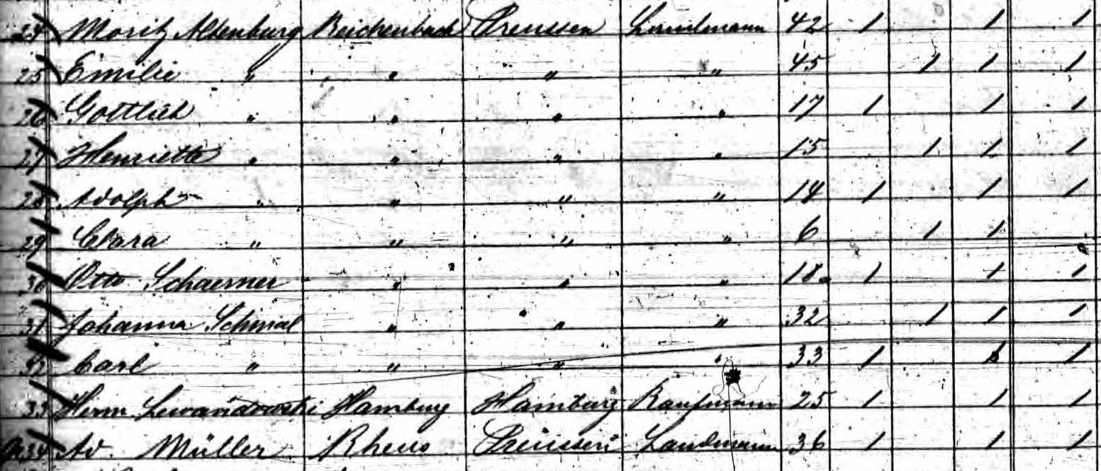

Extract from the passenger list of the Teutonia for departure on 20 October 1857

The iron screw steamer of 2700 BRT was only built in 1856 at the well-known shipyard Caird & Co in Scotland. It was 96m long, 12m wide with a draught of 6.4m and had three masts with sails and a steam engine for slack periods. A crew of 80 men was on board. In 1858 the well-known Hamburger Paketfahrt AG (HAPAG) bought the excellent ship.

In the passenger list Otto is listed as "Otto Schaerner from Reichenbach in Preußen, Landmann". In this list, however, immediately before Otto, there is the family of the farmer Moritz Altenburg, who came from Reichenbach in Silesia and to whom Otto had joined, perhaps for his protection, perhaps also to deceive the departure authorities. According to documents about the settlers in the Blumenau area (Blumenauer Schul-Chronik) it is known that the Altenburgs actually emigrated to Blumenau.

This journey of the Teutonia is - by chance - described in the book of the fellow traveller Dr. Johann Jakob v. Tschudi "Reisen durch Südamerika". He reports:

"The steamboat Elbe took me on October 20, 1857, in the company of numerous other passengers from Hamburg on board the large iron screw steamer Teutonia, owned by the Hamburg-Brazilian Steamship Company, which was ready for departure for Brazil with a full, rich cargo off Glückstadt on the Elbe. The overloading of the mail and the travellers with their many pieces of luggage was quickly accomplished. At 4 o'clock in the afternoon we left Cuxhaven behind us and steamed, accompanied by the most beautiful weather, into the deceptively quiet North Sea.

After a journey of about one month the Teutonia reached South America, more precisely Pernambuco (Recive) on November 17, 1857. The next day the ship continued on to Bahia, where it arrived on November 20. The following Sunday, November 22nd, we left there to reach Rio de Janeiro on November 26th, 1857, where the voyage of the Teutonia and thus also of v. Tschudis' voyage ended".

So the steamship Teutonia did not yet take Otto to the island of Santa Catarina, where the port city of Desterro (her exact name was Nossa-Senhora-do-Desterro) was located on the west coast, renamed Florianopolis in 1893.

The passengers who wanted to go to the colony of Blumenau first had to go through the slow Brazilian customs in Rio de Janeiro. They had the address of an agent in Rio who took them in and organised seats on a coastal sailing boat to the capital of the province of Santa Clara called Desterro (now Florianopolis).

A good week later the stressed out immigrants reached Desterro. It was now January 1858, and from Desterro they took a small coastal sailing boat that took them a little way back north to the mouth of the Itajai River. So Otto Schoerner went to the Brazilian state of Santa Catarina, first to Blumenau. This place had been founded in 1852 by Hermann Blumenau (*1819, +1899) with 17 immigrants as a German settlement.

In this region there were numerous German colonies such as Blumenau, Annaburg, Badenfurt, Santa Theresa, Hansa, Dona Francisca and others.

According to the "Blumenauer Schul-Chronik" Otto came to Blumenau in 1857 in the second half of the year. However, he did not stay there longer, but went to the nearby village of Brusque. Before Otto Schörner immigrated to Brazil, this younger colony was called "Colonia Itajahy". After that it was called "Colonia São Luiz Gonzaga" and finally Brusque. In 1960 the village of Guabiruba separated from the present town of Brusque and is now an independent town. Brusque is only 36 km as the crow flies from Itajai, the port city for Blumenau. Brusque was founded by the Austrian Baron Maximilian v. Schneeburg, a military man.

Luiz Scherner wrote to me that he knows a document from 1863 in which Otto Schoerner and another immigrant applied for a piece of land in the colony of Brusque. They stated that they intended to marry girls from this colony and therefore needed the land. Otto Schörner probably worked in Brusque at first in the nearby jungle, cutting down trees until he found work in a sawmill. On January 11, 1870, the 30-year-old Otto Schoerner married his bride Amalia Wippel, who was only 17 years old, in Brusque. Amalia was the daughter of Peter Wippel and Charitas born Wagner, also from Weiher, born on 30 March 1853 in Weiher in the province of Baden in Germany. Otto Schoerner and Amalia born Wippel had nine children, which I do not want to introduce here yet.

Otto Schoerner successfully worked his way up in Brusque and later became the owner of a sawmill himself. He read German newspapers and corresponded with his brother Carl in Germany. After Otto's death Otto's daughter Anna Augusta kept in touch. She was married to Sebastian Batschauer. At least until 1914 Sebastian Batschauer wrote to Bernhard Muschalek, where Otto Schoerner's sister-in-law Ottilie lived, who was an aunt of Anna Augusta.

Otto Schoerner died at the age of 57 on 31 March 1896 in Brusque from „chest sickness", which was probably a heart attack, and was buried there. His wife outlived him by almost 20 years. She died on 10 May 1915 also in Brusque in Santa Catarina, where she is buried.

